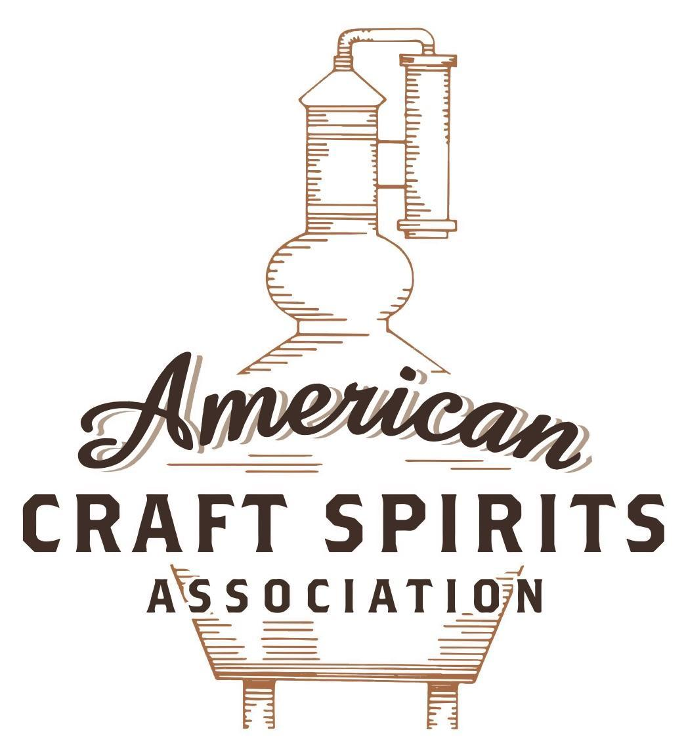
Spirits DtC Shipping Guide

This guide summarizes the direct-to-consumer shipping rules for distilleries in all 50 states and D.C. and also addresses the measures state governments have taken to ease delivery and shipping restrictions during the COVID-19 pandemic.

DtC Quick Guide Comparison

Out-of-State Distilleries  Can Ship Into State? |  |  |  | In-State Distilleries  Can Ship Within State?
State | Yes | No |  | State | Yes | No
AL |  | X |  | AL |  | X
AK | X |  |  | AK | X
AZ | X |  |  | AZ | X
AR |  | X |  | AR |  | X
CA |  | X* |  | CA |  | X*
CO |  | X |  | CO |  | X
CT |  | X* |  | CT |  | X
DE |  | X |  | DE |  | X
DC | X |  |  | DC | X
FL |  | X |  | FL |  | X
GA |  | X |  | GA |  | X
HI |  | X* |  | HI |  | ?*
ID |  | X |  | ID |  | X
IL |  | X* |  | IL |  | X*
IN |  | X |  | IN |  | X
IA |  | X* |  | IA |  | X*
KS |  | X |  | KS |  | X
KY | X |  |  | KY | X
LA |  | X |  | LA |  | X
ME |  | X* |  | ME |  | X*
MD |  | X |  | MD |  | X
MA |  | X |  | MA |  | X
MI |  | X |  | MI |  | X
MN |  | X |  | MN |  | X
MS |  | X |  | MS |  | X
MO |  | X |  | MO |  | X
MT |  | X |  | MT |  | X
NE | X |  |  | NE | X
NV |  | X* |  | NV |  | X
NH | X |  |  | NH |  | X*
NJ |  | X* |  | NJ |  | X*
NM |  | X |  | NM |  | X
NY |  | X* |  | NY |  | X*
NC |  | X |  | NC |  | X
ND | X |  |  | ND | X
OH |  | X |  | OH |  | X
OK |  | X |  | OK |  | X
OR |  | X |  | OR | X
PA |  | X* |  | PA |  | X
RI |  | X* |  | RI |  | X
SC |  | X |  | SC |  | X
SD |  | X |  | SD |  | X
TN |  | X |  | TN |  | X
TX |  | X |  | TX |  | X
UT |  | X |  | UT |  | X
VT |  | X |  | VT |  | X
VA |  | X |  | VA |  | X
WA |  | X* |  | WA | X
WV |  | X* |  | WV |  | X*

WI |  | X |  | WI |  | X
WY |  | X |  | WY |  | X

Notes:
*CA: If passed and signed into law, Senate Bill 620 would allow licensed distilled spirits producers in states other than California and licensed distilled spirits manufacturers or craft distillers in California who obtain distilled spirits direct shipper permits to ship directly to consumers in California
*CT: Consumers with appropriate permit may receive alcohol shipments
*HI: Consumers with appropriate permit may receive alcohol shipments; If passed and signed into law, Senate Bill 65 would allow licensed distilled spirits manufacturers in Hawaii and in states other than Hawaii who obtain direct shipper permits to ship directly to consumers in Hawaii
*IL: If passed and signed into law, Senate Bill 0532 would allow licensed distilled spirits producers in Illinois and in states other than Illinois who obtain distillery shippers’ licenses to ship directly to consumers in Illinois
*IA: If passed and signed into law, House File 639 would allow native distilled spirits manufacturers in Iowa and in states other than Iowa who obtain direct shipper permits to ship directly to consumers in Iowa and to consumers in states other than Iowa
*ME: If passed and signed into law, Legislative Document 1358 would allow distilleries outside of Maine with current manufacturer licenses and distilleries licensed in Maine who obtain spirits direct shipper licenses to ship directly to consumers in Maine
*NJ: (1) If passed and signed into law, Assembly Bill 3167 would allow a craft distillery licensees to ship no more than 9 liters of distilled spirits to a consumer in New Jersey; (2) If passed and signed into law, Senate Bill 3020 would allow craft distillery licensees in New Jersey or in states other than New Jersey to ship no more than 20 liters of distilled spirits to a consumer in New Jersey via common carrier
*NV: Licensed individuals can import one gallon per month of spirits for personal use and the out-of-state supplier must pay excise tax
*NH: If passed and signed into law, Senate Bill 125 would allow licensed liquor manufacturers who obtain direct to consumer shipping permits from the commission to ship directly to consumers in New Hampshire
*NY: Consumer may import up to 90L of liquor per year for personal use without a license; If passed and signed into law, Assembly Bill 3275 would allow licensed liquor manufacturers in states other than New York and licensed distillers and farm distillers in New York to ship no more than thirty-six cases (no more than nine liters per case) of liquor to consumers in New York
*PA: Consumer may place a special liquor order and distiller must ship to a PLCB-operated store
*RI: Distiller can only ship to customer if order was personally placed by customer at distiller's premises
*WA: If passed and signed into law, House Bill 1432 would allow licensed spirits manufacturers in states other than Washington to ship spirits to consumers in Washington
*WV: Distilleries, mini-distilleries, or micro-distilleries licensed in West Virginia or a state other than West Virginia who obtain private direct shipper licenses to ship to a consumer in West Virginia, however the shipments must be made to a retail liquor outlet

NORTH CAROLINA

Shipment Outbound – No, NC law allows out-of-state sales at wholesale or retail to private or public agencies or establishments but does not expressly mention individuals (N.C. Gen. Stat. § 18B-1105(a)(2)).
Shipment Inbound – No, spirits can only be shipped to wholesalers (N.C. Gen. Stat. § 18B-109).
Shipment Intra-state – No, distillers can sell their liquors in closed containers to visitors who tour the distillery for consumption off the premises (N.C. Gen. Stat. § 18B-1105(a)(4)).
COVID-19 Measures – No specific measures regarding shipping or delivery were extended to distilleries. Distilleries were allowed to re-open on May 22, 2020 under Phase 2 reopening.
Citation (shipment)
North Carolina General Statutes
§ 18B-109. Direct shipment of alcoholic beverages into State.
a) General Prohibition. – Except as provided in G.S. 18B-1001.1 [Wine shipper permit], no person shall have any alcoholic beverage mailed or shipped to him from outside this State unless he has the appropriate ABC permit.
§ 18B-102.1. Direct shipments from out-of-state prohibited.
(a) It is unlawful for any person who is an out-of-state retail or wholesale dealer in the business of selling alcoholic beverages to ship or cause to be shipped any alcoholic beverage directly to any North Carolina resident who does not hold a valid wholesaler’s permit under Article 11 of this Chapter.
§ 18B-1105. Authorization of distillery permit.
(a) The holder of a distillery permit may do any of the following:
(1) Manufacture, purchase, import, possess and transport ingredients and equipment used in the distillation of spirituous liquor.
(2) Sell, deliver and ship spirituous liquor in closed containers at wholesale to exporters and local boards within the State, and, subject to the laws of other jurisdictions, at wholesale or retail to private or public agencies or establishments of other states or nations.
(3) Transport into or out of the distillery the maximum amount of liquor allowed under federal law, if the transportation is related to the distilling process.
(4) Sell spirituous liquor distilled at the distillery in closed containers to visitors who tour the distillery for consumption off the premises. Sales under this subdivision are allowed only in a county where the establishment of a county or municipal ABC store has been approved pursuant to G.S. 18B-602(g) and are subject to the time and day restrictions in G.S. 18B-802. Spirituous liquor sold under this subdivision shall (i) be listed as a code item for sale in the State, (ii) be sold at the price set by the Commission for the code item pursuant to G.S. 18B-804(b), and (iii) have affixed to its bottle any labeling requirements set by law.
Link to Section 18B: https://www.ncleg.gov/EnactedLegislation/Statutes/HTML/ByChapter/Chapter_18B.html
14B NCAC 15A .2102 Retail Sales At Distillery's Permitted Premises
(d) The distillery permittee shall not sell any bottle of spirituous liquor to a consumer until after the consumer has completed a tour of the distillery.
Link:
http://reports.oah.state.nc.us/ncac/title%2014b%20-%20public%20safety/chapter%2015%20-%20alcoholic%20beverage%20control%20commission/subchapter%20a/14b%20ncac%2015a%20.2102.pdf

The American Craft Spirits Association (ACSA) is working diligently to give our members and industry partners relevant, current updates on statutes and regulations impacting production, sale and distribution of spirits. With the declaration of the novel coronavirus (COVID-19) in early 2020, many states have issued temporary policy changes or longer-term modernization of alcohol beverage laws. State statutes, regulations created by the state alcohol regulatory authority, as well as any other relevant guidance provided by such authorities (such as advisories, opinions, bulletins, etc.) were reviewed in creation of this document. No city or county ordinances were reviewed. Distillers should be aware that even in states where direct shipping is permissible, always remember to avoid shipping to dry counties. Please consult with your state guild or alcohol beverage authority for the most up-to-date information. This content is intended for educational and informational purposes only. ACSA's pro bono law firm of Malkin Law P.A. provided the core content found in this comprehensive overview of the spirits distribution after COVID-19. It was completed in August 2021 and will be updated regularly.If you have updates you would like to provide, please send to legislation@americancraftspirits.org or directly to the law firm at: ryan@malkin.law / malkin.law. Thank you.
H.B. 890, introduced on May 4, 2021, would allow a holder of a distillery permit to sell, deliver, and ship spirituous liquor in closed containers to consumers in other states, except that the holder of a distillery permit may not sell, deliver, or ship spirituous liquor to consumers in jurisdictions that require reciprocity in order to allow such sales, deliveries, or shipments. The bill is in committee. Link: https://www.ncleg.gov/Sessions/2021/Bills/House/PDF/H890v3.pdf

